12.5: a) Denoting the earth-sun separation as R and the distance from the earth as x, the distance for which the forces balance is obtained from
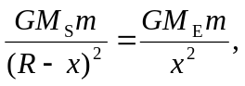
which is solved for
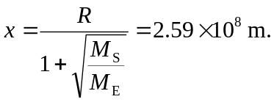

b) The ship could not be at equilibrium for long, in that the point where the forces balance is moving in a circle, and to move in that circle requires some force. The spaceship could continue toward the sun with a good navigator on board.

